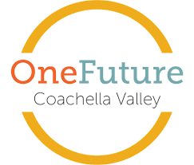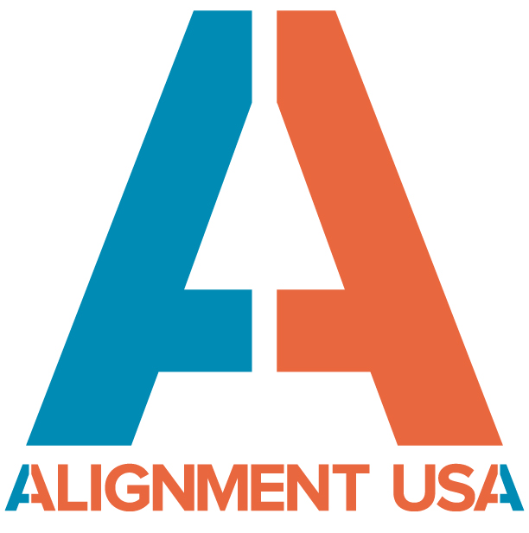

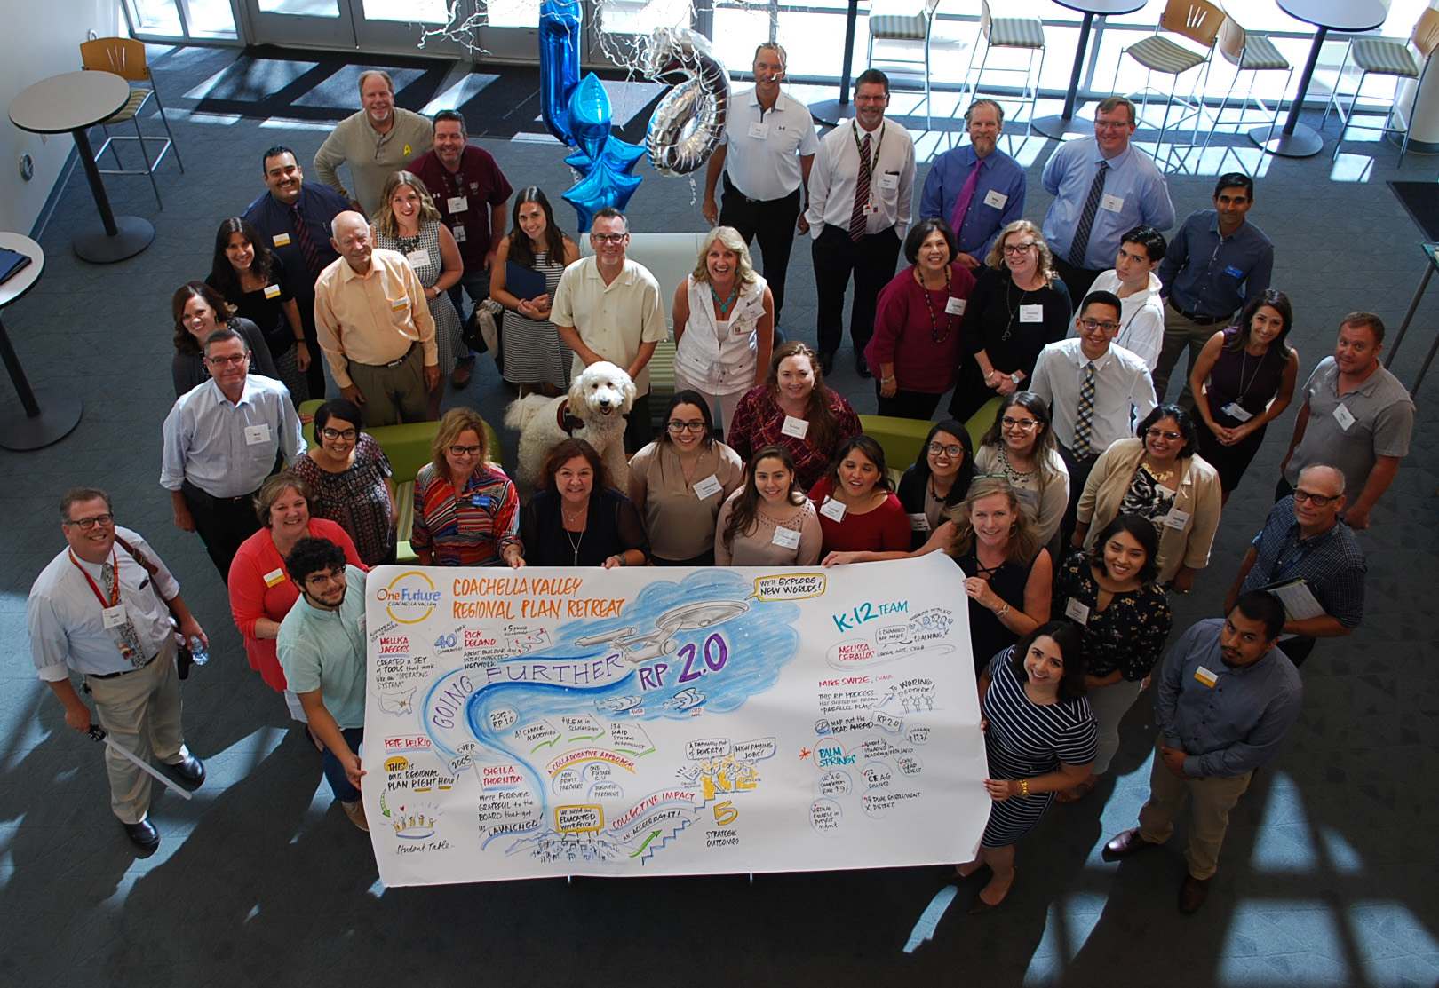

**Coachella Valley Regional Plan 2.0 College and Career Success Framework**

**Working Draft – Version. December 4, 2018**

**Long Term Outcomes:**

* Increase High School Graduation Rates
* Increase College Readiness
* Increase College/Higher Skills Completion
* Increase Career Readiness
* Place Local Students in Higher Wage Jobs

**A 3-Year Action Framework** (builds upon and expands 4-Strand framework used for RP 1.0)

Strand 1: Transforming Teaching and Learning:  Strand 4: Expanding College Access

Strand 2: Transforming the K-16 School Experience  Strand 5: Securing a Financial Path

Strand 3: Transforming Business and Civic Engagement Strand 6: Increasing College Completion

**Regional Plan 2.0**

In April 2017, a Design Team comprised of representatives of all three K-12 districts, COD, CSUSB, UCR and business began work, with support from Ford Next Generation Learning (Ford NGL) and Alignment USA, to vision and design a framework for “Regional Plan 2.0” – the renewal of the original Coachella Valley Regional Plan for College and Career Success written and adopted in 2012. The team agreed upon a six strand framework, building upon accomplishments achieved through the original plan.

In September 2017, seventy stakeholders representing K-20 education, foundations, philanthropy, business, government, nonprofits and students, gathered to begin writing Regional Plan 2.0. Four Strand Writing Teams were formed and an initial draft of the plan sections were written between October 2017 and May 2018. A draft was shared with the Regional Plan Oversight Committee for an initial review and suggestions for refinement and next steps on May 24, 2018. That plan was then shared with each of the existing Alignment Teams for their review and input.

**Career and College: The Linked Learning Approach and College Success**

RP 2.0 includes a specific focus on student success across college and career, including emphasis on financial aid capture, regional aligned scholarship giving and an emerging college compact. There is also a focus on rigor and relevance, which links student learning to the world of work. The Linked Learning approach transforms students’ high school experience bringing together strong academics, demanding technical education, and real-world experience that helps students gain an advantage in high school, postsecondary education, and careers. In the Coachella Valley, Linked Learning is delivered through the career academy model. Linked Learning students follow industry-themed pathways in a wide range of fields, and these pathways prepare high school students for career and a full range of post-secondary options, including 2- or 4-year college or university, an apprenticeship, the military, and formal employment training.

| **RP 2.0 Strand** | **Tactics** | **Outputs/Outcomes** | **Suggested A-Team** |
| --- | --- | --- | --- |
| **Strand 1:**  **Transforming Teaching and Learning**  Create meaningful learning experiences that enable students to learn and apply academic, 21st century, and technical knowledge and skills to real-world challenges | **Tactic 1:** Host collaborative planning time for academic teachers in academies by subject and academy sector. | * All academic and CTE teachers within academies will have regular collaboration opportunities annually. | K-12 Engagement |
| **Tactic 2**: Create meaningful learning experiences that enable students to learn and apply academic, 21st Century and technical knowledge and skills to real world challenges. | * Each district will meet their identified LCAP progress metric for students who score “Standard Met” or “Exceeded” in ELA on CAASPP (CA Assessment of Student Performance and Progress) * Each district will meet their identified LCAP progress metric for students who score “Standard Met” or “Exceeded” in Mathematics on CAASPP (CA Assessment of Student Performance and Progress) * Each district will meet their identified LCAP progress metric for secondary students who are identified as “Prepared” on CCI Indicator. * Technical Knowledge - Each district will create a culture that is clearly established around the willingness to embrace new ideas and proactively use technology by continually infusing local and global best practices, current trends, and future projections into all conversations about teaching and learning. * Technical Knowledge - Through training and regular use of technology, staff will incorporate the right technology tool ensuring our students have opportunities to learn and share knowledge that would otherwise be unimaginable. | K-12 Engagement |
| **Tactic 3**: Equip parents to connect their children to a career path. | * A plan is created to educate all parents on CCI and the Career Awareness Continuum so they are able to support their students’ college and career aspirations. * Introduce C2Navigator resource. | K-12 Engagement |
| **Strand 2:**  **Transforming the K-16 School Experience**  Creating and maintaining career- and interest-themed academies / pathways and collaborative culture, structures and practices K-16  **Strand 2:**  **Transforming the K-16 School Experience** | **Tactic 1**: Equip post-secondary and community partners to connect students to a career path. | * A plan is created and implemented to educate post-secondary and community partners on CCI and the Career Awareness Continuum so that all can support students on their education/career path. * Introduce C2Navigator resource. | K-12 Engagement  BE  BH  College Completion |
| **Tactic 2:** Provide opportunities/structures for horizontal and vertical articulation between K-16 to develop lessons, tasks, curriculum and other learning opportunities within the career and interest themed programs/pathways so that students are prepared to transition directly to college-level coursework upon high school graduation. | * 10% increase in number of students who persist and succeed in 2nd year post-secondary courses. (Possible Steps: Engage parents and community partners in support of this metric; Define barriers to persistence; Identify ways to secure qualitative data specific to all student persistence.) | K-12 Engagement  College Completion |
| **Tactic 3:** All students will be exposed to college and career through a variety of programs spanning all education levels. | * Increase in number of students earning college credit while in high school. Use 2017-2018 data as baseline. | K-12 Engagement  College Completion  BE  BH  OYYA |
| **Strand 3:**  **Transforming Business & Civic Engagement**    Engaging employers, educators, workforce and community leaders in building and sustaining a transformed K-16 school experience and college completion focus aligned with workforce needs in promising industry sectors.  **Strand 3:**  **Transforming Business & Civic Engagement** | **Tactic 1:** Expand Work-Based Learning opportunities. Develop a “how to” guide for providing/hosting WBL experiences through business, civic and non-profit partner sites. | * 10 major employers agree to: 1) Adopt the Essential Skills definitions developed by the BE A-Team, 2) Define an internal staff process for reinforcing the Essential Skills with their Work-Based Learning students, and 3) Establish a staff lead for the project. * Develop and deliver a one-day “Essential Skills” training for all Academy/CTE Pathway Teachers in 2019 to build common understanding about the value and importance of these skills to local employers so that teachers can effectively embed practice into their curriculum. Workshop will be presented with participation of Business Engagement A-Team members, including Eisenhower Health, Greater Palm Springs CVB, JW Marriot Desert Springs Resort, Avid Physical Therapy, Sunline Transit Agency and the Department of Rehab * Establish and regularly deliver an onboarding training process for new partners. * 10% increase in number of available WBL spots in participating employers. * Adopt a Regional Sequence for Student WBL Experience and push down to academy level: 1) WBL Continuum, 2) WBL Definitions, 3) Essential Skills, 4) WBL Agreement, 5) Common paperwork, 6) Business Partner Onboarding, 7) Orientation meeting for parents and business | BE  K-12 Engagement  BH  OYYA |
| **Tactic 2:** Align available public funding resources as incentives to employers to engage in support WBL opportunity for students.Raise the awareness of legislative issues and needs in support of CTE and how community partners can engage in the process. (Student Loan Reimbursement. County Incentives. $ for Employers) | * Complete exploration of potential public funding support through Riverside County EDA or other. * 2 industry pathways receive increased public funding support for OJT or WBL. * Identify and support new legislation specific to creating employer incentives for WBL. | BE  K-12 Engagement  OYYA |
| **Tactic 3:** Establish regional advisories inclusive of K-16 partners, counselors, WIOA, Business/Industry, Parents & Students. | * Through the BE A-Team, engage Community College Deputy Sector Navigators (DSN)s to work in partnership with BE A-Team to convene and align **at least one regional advisory for all common industry sectors** in the CV. | BE  K-12 Engagement  BH  OYYA |
| **Tactic 4:** Create a regional marketing campaign/plan with reach to engage more businesses in the Coachella Valley to support K-16 career pipeline activities and includes a campaign goal to solicit and expand funding for scholarships and regional plan efforts. | * A regional marketing plan to engage business and community in support of K-16 career pipeline activities, including expanding funding for scholarships and regional plan efforts is created by December 2019. | BE Strategic Marketing Team  K-12 Engagement |
| **Tactic 5:** Identify relevant third party work readiness assessments and digital badges recognized by local business that students my complete to demonstrate work readiness. | * 75% of career- and interested themed pathway students will earn Industry certification or a recognized third party work-readiness certification. | BE  K-12 Engagement  College Completion  Data |
| **Strand 4:**  **Expanding College Access**  Increasing accelerated credit opportunities;  decreasing remediation; increasing parent engagement; intersegmental alignment of counseling, support, both academic and CTE curriculum.  **Strand 4:**  **Expanding College/Post-Secondary Access** | **Tactic 1:**  Align all identified college and career readiness programs ensuring that at least one course in a program of study is offered as Dual/Concurrent enrollment or articulated for college credit. | * Define “program of study” and establish existing number of Dual/Concurrent enrollment and articulated courses for each “program of study” as a baseline. | K-12 Engagement  College Completion |
| **Tactic 2:** Create an intersegmental Counselor Workgroup focused on aligning regional common practices and expectations to ensure awareness of post-secondary opportunities for all students. | * Each district will significantly increase and at a minimum meet their identified LCAP progress metric for increasing a-g completion. * A common Behavioral Health indicator is established for all students. * Create a Counselor Preparation Program for professional development specifically for counselors on Career Assessment and how high school pathways and post-secondary completion can help them secure their desired careers. | K-12 Engagement  College Completion |
| **Tactic 3:** Reduce barriers to access and ability to navigate and achieve post-secondary completion (i.e. cultural barriers, access to information, awareness/education about options-value-feasibility, transportation, immigration, financial aid for all demographics, systemic poverty, experience) | * Establish a way to collectively measure the increase in number/percentage of students entering college with college level course credits. * X% increase in Baccalaureate degree completion * X% increase in ADT completion * X% increase in credential/certificate programs * X% reduction in time to degree completion * Close the college achievement gap for Hispanic students. | K-12 Engagement  College Completion  NOTE: Baselines will be identified from RCOE/College data, and % increases recommended from that – anticipate Jan 2019 |
| **Tactic 4:** Provide early awareness and education of post-secondary opportunities for parents, guardians, supporters & students. Ensure all materials and programs are inclusive and culturally relevant. | * Work with districts to use existing parent engagement resources to reach x% of parents and avoid duplication (an extension of strand 1, tactic 3) * Continue ELAC and DLAC tri-district meetings in partnership with post-secondary, and include college awareness, and post-secondary education, as a standing agenda item. * Work with Spanish media partners to share college access and completion resources. | K-12 Engagement  College Completion  OYYA  BH  Financial Aid |
|  |
| **Tactic 5:** Promote regional College and Career Navigator ([www.ofcv.c2nav.com](http://www.ofcv.c2nav.com)) website with expanded parent/student resources to all students beginning in grade 9. | * X% of seniors complete a C2Nav profile and/or CaliforniaColleges.edu profile * Create a single sign-on option for student college resource systems. | K-12 Engagement  College Completion  OYYA  BH  Financial Aid |
| **Strand 5:**  **Securing a Financial Path**  Scaling and aligning regional scholarship giving and increasing financial aid capture to address unmet needs. | **Tactic 1:**  Expose potential donors to the great work local students are doing through regional showcase events, and other activities/programs and identify financial aid need gaps. | * Establish a common fund that generates $3 million annually to catalyze increased scholarship giving * Develop a crowd-funding strategy to close the financial need gap among local students pursuing a higher education. | Financial Aid  BE: Strategic Marketing Team |
| **Tactic 2:** Continue FAFSA completion strategy with goal of 85% completion and systemically embed strategies underway in our schools and districts K-16. | * Continue regional FAFSA Competition and maintain 85% completion goal. * Work with districts to make FAFSA a high school graduation requirement. | Financial Aid  K-12 Engagement  College Completion |
| **Tactic 3:** Focus on financial aid package review and advising for not awarded scholarship students. | * Develop a differentiated approach to provide financial aid for all (i.e. City funds for students, etc.) * Use data on financial aid gap from OFCV scholarship students to better define gaps for potential funders. | Financial Aid  College Completion  K-12 Engagement |
| **Tactic 4:** Public awareness campaign to showcase students and outcomes & return on investment (ROI) – really encompasses ALL. | * Develop a Communications Plan * Create a Spanish media campaign * Engage Counselors * Embed outreach in classrooms and district systems | BE  K-12 Engagement  Financial Aid |
| **Tactic 5:** Clarify the application process and information specific to Financial Aid for Parents | * Create a Parent Tool on the C2nav portal * Develop an easy to understand handout in English and Spanish (check resource guide) | Financial Aid |
| **Strand 6:**  Increasing College Completion  **Strand 6:**  Increasing College Completion  Ensuring students complete a degree, certificate or credential to succeed in chosen careers, thus generating a quality workforce for local employers and economic opportunity for students. | **Tactic 1:** Ensure all students complete a post-high school college and career plan, including a financial path to and through post-secondary. | * 100% of students complete a college and career plan by 9th grade. * 100% of students have a financial plan for post-secondary at graduation. * 100% of students complete a “Match & Fit” college assessment | K-12 Engagement  College Completion |
| **Tactic 2:** Design a Coachella Valley Education Compact that defines local higher educations’ commitment and connection to K-12 strategies, student access and completion through a promise-like structure. This structure will include a focus on the needs of Linked Learning pathway/career academy students, for whom high school graduation and college enrollment rates are higher, but college persistence is not.  NOTE: Elements in ***bold/italic\**** are priorities unanimously identified by K-12 Superintendents Lyon, Bailey and Gomez in meeting with College Completion A-Team C0-Chair, CSUSB-PD Dean Welty in May 2018. | * **Addressing Gaps in Readines**s: Provide coursework and programs to ensure smooth matriculation fromK-12 to post-secondary to include support classes, summer bridge programs, and other supplemental programs such as transportation and childcare.   + ***College Success Class\****   + ***Summer Bridge Program to Remediate Gaps in College Readiness\****   + Opportunity for Class Credit for Attending College & University Public Lectures   + College Credit for Math and English Remediation   + ***Dual Enrollment Pathways at All High Schools\****   + ***Dual Enrollment\****   + Supplemental Instruction   + Include Adult Students from K-12 Districts   + Remove Transportation Barriers   + Day Care * **Alignment Across Segments**: Through collaborative efforts, align curriculum and programs between all sectors.   + ASD & ATDs for All University and College Offerings   + Plan to Accommodate Reverse Transfers   + Align a-g Content with College Expectations of Proficiency   + ***Common PLCs K-12-CC –University (By Discipline)\**** * **Meeting Milestones**: Create and set a series of milestones to ensure and accelerate progress toward, and completion of, college and career preparation.   + Guarantee College Grad in 4 Years   + All Students Who Enter Complete Degree, Certificate or Credential   + Accept to University or CC at End of Junior Year of High School   + Guaranteed Admission Upon Program Completion & Minimum Qualifications   + Career Counseling and Pathway Planning Aligned at K-16 Markers.   + All High School Students Have Opportunity to Take a-g Courses.   + All Students Complete Cross-Institution Plan by Senior Year.   + All Students Complete 1 Year of College by Senior Year. | College Completion  K-12 Engagement  Business Engagement |
| **Strand 6:**  Increasing College Completion |  | * **Engaging Employers and Community**: Engaging employers and the community to guarantee paths to full employment and volunteer opportunities.   + 20 Major Employers Hire Top Candidates from CV Colleges Universities and career preparation programs.   + Volunteer Opportunities with Non-Profits, Middle School on up – Required Service Learning * **Structure Support and Guidance**: Provide structured support and guidance tools and resources to ensure successful student progression K-16.   + Mentoring & Intervention (tutoring) for Students at All Levels.   + Counselors Monitoring and Intervening for Student Success   + Student to Student Mentorship Program.   + Coordinated Career Mentoring. |  |
|  |  | * **Post-Secondary & Financial Literacy**: Securing financial literacy and post-secondary resources for families, students and community partners.   + Guide Families through College & Financial Aid Application/Process.   + Clear Marketing Message to Parents, Staff & Students   + Financial Aid Gap is calculated for Every Senior by May.   + Program & Activities for K-12 at Colleges and Universities (Include Parents)   + Every Local Student Has Full Financial Aid Gap Met (for Local Higher Education Institutions)   + Fully Funded Book Exchange Program Across All Segments   + Full Ride Scholarship for Those Who Demonstrate Ability to Succeed.   + Centralized, Web-Based Data Repository for Education Partners.   + Centralized, Web-Based Data/Information Site for Parents & Students. |  |
| **Tactic 3:** Explore innovative best practices to increase post-secondary completion. | * Review High Impact Practices (HIP)- standard post-secondary framework | College Completion |
| **Tactic 4:** Create local employment pipeline agreements with business to ensure CV graduates secure jobs. | * Provide career exploration opportunities for All Students * Give special employment consideration for local students / grads. * Educate students on the potential career trajectory if they complete college. * Establish a check-in structure (connection to Campus Career Centers, Job Fair, Job Shadows, Mixers, etc.) for college students to remain connected to the Coachella Valley throughout college so they return after graduation. | BE  K-12 Engagement  College Completion |

